Science Fair

Project Packet
Types of Science Projects:
There are two types of science projects: Models and Experiments. Here is the
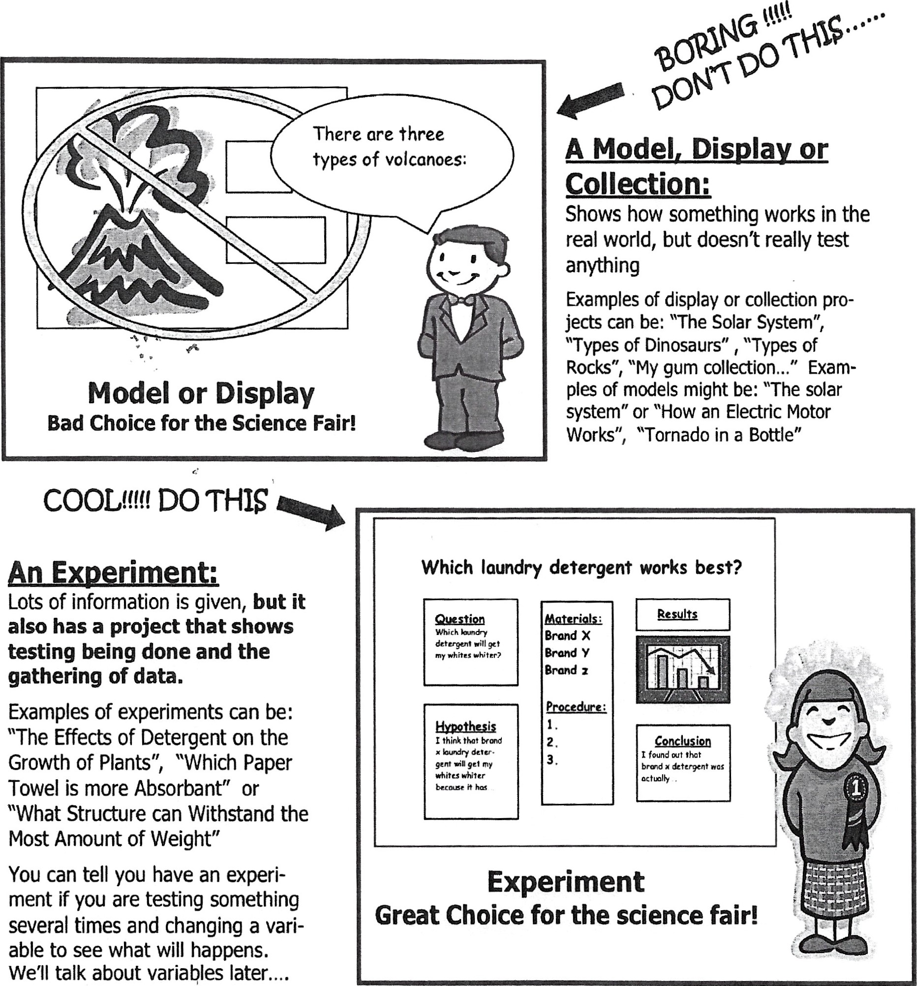
difference
between
the
two:
so What Type of Project Should You DO?
Even though you can learn a lot from building a model or display, we recommend that you do an Experiment!!! Why? Well, they are fun, they are more interesting and most of all, they take you through the SCIENTIFIC METHOD, which is the way real scientists investigate in real science labs. Besides that, the scientific method is what the judges are looking for!!
go What the Heck js the Scjentjfjc Method?
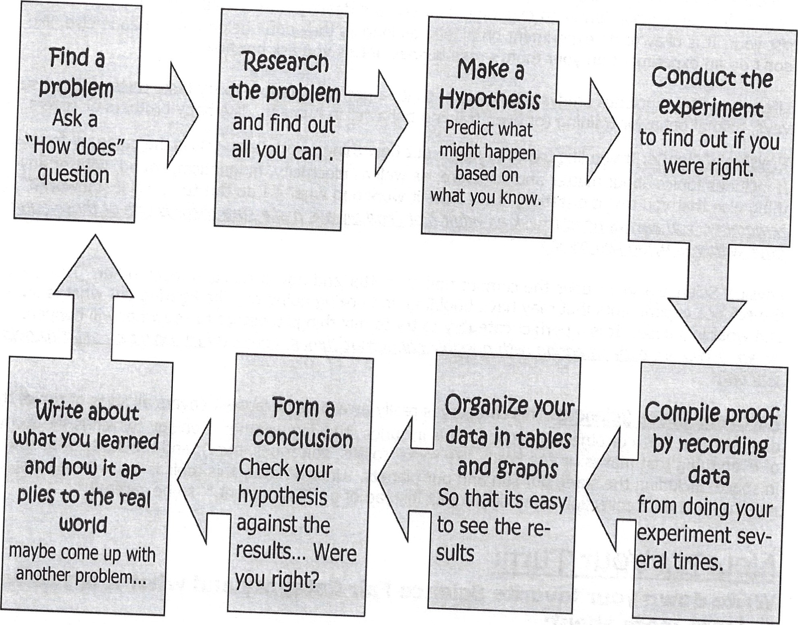
Choosing a category that interests YOU...
All Great Projects start with great questions but before you get started on a great question you need to pick a subject or topic that you like. There are three different categories of the Science Fair to choose from. They are:
L!.fe..SCED-EThis category deals with all animal, plant and human body questions that you might have and want to do an experiment about. Remember that it is against Science Fair Rules to intentionally hurt an animal during an experiment. If you are dealing with animals, please let an adult assist you. It is okay to do experiment on plants, as long as they don't belong to someone else, like don't do an experiment on your mom's rose bushes unless you ask her first...
Life science also includes studying behaviors, so its a perfect category to try taste tests, opinion surveys, animal behavior training (or even training behavior in humans...like baby brothers or sisters...)
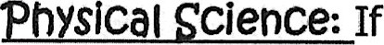you like trying to figure out how things work, then this is the category for you! It includes topics about matter and structure, as well as electricity, magnetism, sound, light or anything else that you might question, "How does it work and what if I do this to it, will it still work?" But
Physical Science also includes the composition of matter and how it reacts to each other. These are the science experiments that may have bubbling and oozing going on, like figuring out what is an acid and what is a base. It is a perfect category to try to mix things together to see what will happen.
r
Earth and Space Sciences: This category is really awesome because it covers all sorts of topics that deal with the Earth or objects in space. This includes studying weather, Geology (which is the study of everything that makes up the Earth, like rocks, fossils, volcanoes, etc..), and the study of all that is in space, including the stars, our sun and our planets. Unfortunately this topic is also where most kids mess up and do a collection or model project instead of an "Experiment," so be careful!!!
Now it's Your Turn:
Write down your favorite Science Fair Category and what it is you want to learn more about:
My favorite Category was

(Life Science, Physical Science, Earth and Space Science)
I want to do an experiment involving

Step 1: Comjng up wjth a Good QUestjon,o.
Now that you have picked out a topic that you like and that you are interested in, it's time to write a question or identify a problem within that topic. To give you an idea of what we mean you can start off by filling in the question blanks with the following list of words:
The Effect Question:
What is the effect of
sunlight | on the growth of plants
eye color | pupil dialation
brands of soda | a piece of meat
temperature | the size of a balloon
oil | a ramp
The HOW Does AffeCt Question:
How does the affect
color of light | the growth of plants
humidity | the growth of fungi
color of a material | its absorption of heat
The Whjch/What and Verb Question
Which/What (verb)
paper towel | is | most absorbent
foods | do | meal worms prefer
detergent | makes | the most bubbles
paper towel | is | strongest
peanut butter | tastes | the best
Now its your turn:
Create your Science Fair question using either the "Effect Question", the "How does Affect Question" or the "Which/What and Verb Question":

Step 2 : Doing the Research and forming a HypotheSjS
So you've picked your category and you've chosen a topic. You even wrote a question using our cool fill in the blank template. Now it is time to research your problem as much as possible. Becoming an expert at your topic is what real scientists do in real labs.
go How do You become an expert? 
YOU READ!!!!
READ about your topic. READ encyclopedias. READ magazine articles and books from the library. READ articles from the internet. Take note of any new science words you learn and use them. It makes you sound more like a real scientist. Keep Track of all the books and articles you read. You'll need that list for later.
YOU DISCUSS!!
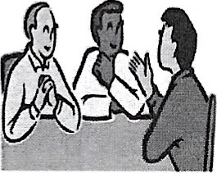
Talk about it with your parents. Talk about it with your teachers. Talk about it with experts like Veterinarians, Doctors, Weathermen or others who work with the things you are studying. Sometimes websites will give you e-mail addresses to experts who can answer questions.... B in on t writ t n neon h internet with
( *hint: take pictures of yourself interviewing people)

Whew
Then when you think that you can't possibly learn anymore and the information just keeps repeating itself.. You are ready to...

Write a Hypothesis
Now it is the time to PREDICT what you think will happen if you test your problem. This type of "SMART GUESS" or PREDICTION is what real scientists call A HYPOTHESIS. Using this fancy word will amaze your friends and will have you thinking like a full fledged scientist.
So how do you begin? Well, just answer this very simple question:
What do you thjnK will happen, (even before you start your experiment)?
Example Problem:  Example Hypothesis: | Which Paper Towe/ is more absorbent?  I think Brand X wi// be more absorbent because it's a more popular brand, it is thicker and the people I interviewed said
that the more expensive brands would work better
(This hypothesis not only predicts what will happen in the experiment, but also shows that the "Scientist" used research to back up his prediction.)
Now its your turn:
Write down the problem and create a Hypothesis based on what you have researched.
Problem:

Research: My problem is about this subject:
(sample topics could be magnetism, electricity, buoyancy, absorbency, taste, plant growth, simple machines or other scientific topics that relate to your problem. If you are having problems finding out what the topic is, ask your teacher or an adult to help you on this one....)
Books I found in the library on my topic are:
Title: Author:

Internet sites that I found on my topic are:

People I talked to about my topic are:

Some important points that I learned about my topic are

Hypothesis: I think that

(will happen) because (my research shows...)

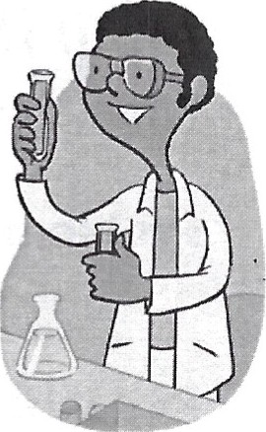
Step 3: Testing your Hypothesis by doing an experiment
Now we've come to the good part. The part that all scientists can't wait to get their grubby little hands on... you guessed it... The EXPERIMENT!
Designing an experiment is really cool because you get to use your imagination to come up with a test for your problem, and most of all, you get to prove (or disprove) your Hypothesis. Now Science Fair Rules state that you cannot perform your experiment live, so you'll have to take plenty of pictures as you go through these seven very simple steps.
First: Gather up your materials. What will you need to perform your experiment? The safest way to do this is get that adult you recruited to help you get the stuff you need. Oh, did we mention to take pictures or draw pictures of your materials. This will come in handy when you are making your board display.
Second: Writea PROCEDURE. A procedure is a list of steps that you did to perform an experiment. Why do you need to write it down? Well it's like giving someone a recipe to your favorite dish. If they want to try it, they can follow your steps to test if its true. Scientists do this so that people will believe that they did the experiment and also to let other people test what they found out. Did we mention to take pictures of yourself doing the steps?
Third: Identify pur variables, The variables are any factors that can change in an experiment. Remember that when you are testing your experiment you should only test one variable at a time in order to get accurate results. In other words, if you want to test the affect that water has on plant growth, then all the plants you test should be in the same conditions, these are called controlled variables: same type of dirt, same type of plant, same type of location, same amount of sunlight, etc. The only variable you would change from plant to plant would be the amount of water it received. This is called the independent or manipulated variable. The independent variable is the factor you are testing. The results of the test that you do are called the dependent or responding variables. The responding variable is what happens as a result of your test. Knowing what your variables are is very important because if you don't know them you won't be able to collect your data or read your results.
Fourth: TEST, TEST, TEST. Remember that the judges expect your results to be consistent in order to be a good experiment, in other words, when you cook from a recipe you expect the outcomes to be the same if you followed the directions (or procedure) step by step. So that means you need to do the experiment more than once in order to test it properly. We recommend five times or more. More is better! Don't forget to take pictures of the science project being done and the results.
F^{i}f^{t}h: Col.-ecLy-Q—r-.2ATA This means write down or record the results of the experiment every time you test it. Be sure You also need to organize it in a way that it is easy to read the results. Most scientists use tables, graphs and other organizers to show their results. Organizing makes the results easy to read, and much easier to recognize patterns that might be occurring in your results. (Besides, it impresses the judges when you use them.) But don't make a graph or table because we asked you to, use it to benefit your project and to help you make sense of the results. There is nothing worse than having graphs and tables that have nothing to do with answering the question of a science project.
Time out: How Do You Collect Data?!!?
- Keep a science journal: A science journal is a type of science diary that you can keep especially if your experiment is taking place over a long period of time. We suggest you do that if your experiment is over a period of a week or more. In your journal you can record observations, collect research, draw and diagram pictures and jot down any additional questions you might have for later.
Have the right tools to do the job: make sure you have the stuff you need to take accurate measurements like rulers, meter tapes, thermometers, graduated cylinders or measuring cups that measure volume. The recommended standard of measurement in science is metric so if you can keep your measurements in meters, liters, Celsius, grams, etc, you are doing great!
Plant | Amount of water per day | Size it grew in two weeks
(controlled variable) | (independent variable) | (responding variable)
Plant A | none | .5 cm
Plant B | 5 ml | 2 cm
Plant C | 10 ml | 5 cm
Plant D | 20 ml | 7 cm
- Tables, charts and diagrams are generally the way a good scientist like you would keep track of your experiment trials. Remember you are testing at least 5 times or more. A table is organized in columns and rows and ALWAYS has labels or headings telling what the columns or rows mean. You will probably need a row for every time you did the experiment and a column telling what the independent variable was (what you tested) and the responding variable (the result that happened because of the independent variable)
- Be accurate and neat! When you are writing your tables and charts please make sure that you record your data in the correct column or row, that you write neatly, and most of all that you record your data as soon as you collect it SO YOU DON'T FORGET WHAT HAPPENED!!!! Sometimes an experiment might be hard to explain with just a table, so if you have to draw and label a diagram (or picture) to explain what happened, it is recommended that you do.
e Use the right graph for your experiment. There is nothing worse than a bad graph. There are all types of graph designs, but these seem to be easy to use for science fair experiments.
Pie graphs are good to use if you are showing percentages of groups. Remember that you cant have more than 100% and all the pieces need to add up to 100%. This type of graph is great if you are doing surveys
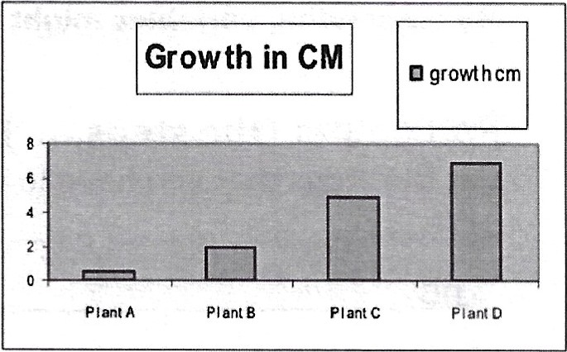
Bar graphs are good to use if you are comparing amounts of things because the bars show those amounts in an easy to read way. This way the judges will be able to tell your results at a glance. Usually the bars go up and down. The x axis (or horizontal axis) is where you label what is being measured, (like plant A, B, C and D) and the y axis (or vertical axis) is labeled to show the unit being measured (in this case it would be centimeters that the plant grew)
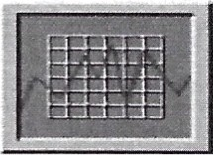
0 Line graphs are good to use if you are showing how changes occurred in your experiments over time. In this particular case you would be using the x axis to show the time increments (minutes, hours, days, weeks, months) and then you would use the Y axis to show what you were measuring at that point in time.

..,.And Now baCK to the Experiment Steps
Sixth: Writea Conclusion: tell us what happened. Was your hypothesis right or wrong or neither? Were you successful, did it turn out okay? Would you change anything about the experiment or are you curious about something else now that you've completed your experiment. And most of all, TELL WHAT YOU LEARNED FROM DOING THIS.
Seventh: Uadeætaad-i&-åæliøtiaa. Write about how this experiment can be used in a real life situation. Why was it important to know about it?
Now it's Your turn
Materials: (take pictures!)
List the Materials that you will need for your science experiment here:
1. 6.
2.
- 8.

- 9.
- 10.

Variables:
List the variables that you will control, the variable that you will change and the variables that will be the results of your experiment:
My controlled variables are (the stuff that will always stay the same):

My independent variable is (this is the thing that changes from one experiment to the next, it is what you are testing):
My responding variables might be (in other words, the results of the experiment)
Procedure: (the steps.... Don't forget to take pictures)
List the steps that you have to do in order to perform the experiment here: 1st
2nd

3rd
4th
5th

Design a table or chart here to collect your information
(Did we mention that you needed to take pictures of you doing the actual experiment?)
Use the Graph paper at the end of this booklet to make a graph of your results from your tablew
ConclUsjon:
Now tell us what you learned from this and if you were able to prove your hypothesis. Did it work? Why did it work or why didn't it work? What did the results tell you? Sometimes not being able to prove a hypothesis is important because you still proved something. What did you prove?

Appljcatjon:
(How does this apply to real life?)
Its important to know about this experiment because

Step q: The Presentation or Why You needed all those pictures....
But First, a school Fable
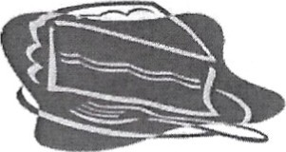
Sammy and Sally both baked cakes for the bake sale with the same cake mix and by following the same directions. When Sammy got his cake out of the oven, he carefully took it out of the pan, smoothed the chocolate frosting neatly and decorated his cake so that it looked delicious. Sally on the other hand, smashed her cake slightly when getting it out of the pan and globbed the frosting on parts of the cake. As you may have already guessed, everyone wanted some of Sammy's cake and no one wanted Sally's. Sally couldn't figure out why, because she tasted both and they both tasted the same.. A good display is
You may have become the leading expert of your topic and had the most interesting experiment results, but if you ^{a Piece o}'^{cake} don't make your science project look delicious for the judges eyes to see, well, your chances of winning sweepstakes will crumble like Sally's cake. Your display board is kind of like an advertisement for all your hard work. So take our advice: BE NEAT!! The judges like to see a nice, easy to read display, that has neat writing, easy to read graphs and tables and you guessed it lots and lots of pictures!! (Did you remember to take pictures?)

MAKING A MOUTH WATERING DISPLAY
This is an example of a neat looking Science Fair Display Board. It is just an example. Depending on your information and the amount pictures, tables and graphs, you may have a different layout. Just make sure it is neat.
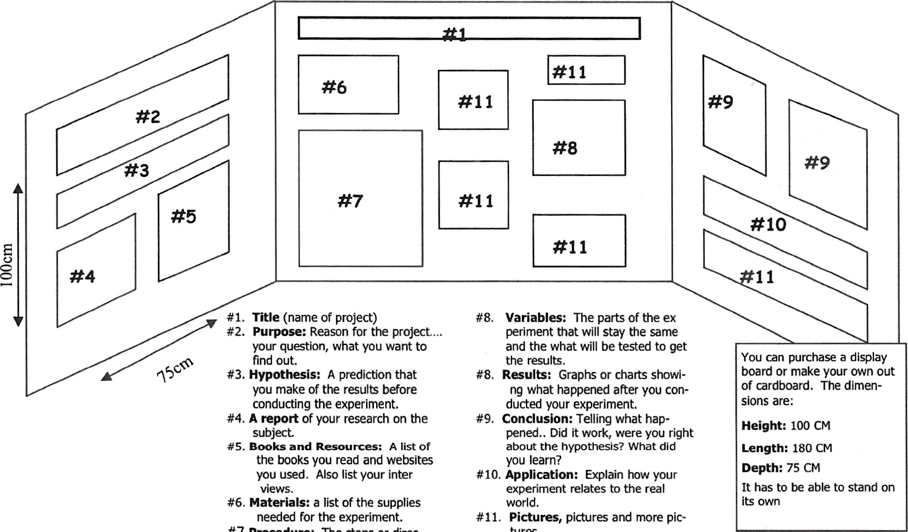
#3. Hypothesis: A prediction that #8. Results: Graphs or charts showiyou make of the results before ng what happened after you conconducting the experiment. ducted your experiment.
180cm
#7
Procedure:
The
steps
or
direc-
tures...
tions
that
you
used
to
conduct
the
experiment.
#4. A report of your research on the #9. Conclusion: Telling what hapsubject. pened.. Did it work, were you right
#5. Books and Resources: A list of about the hypothesis? What did the books you read and websites you learn?
you used. Also list your inter #10. Application: Explain how your views. experiment relates to the real #6. Materials: a list of the supplies world.
Display Beauty Secrets:
Use a computer to type out your information, but if you cant, write out your information in your best writing. Printing the titles is usually best. If you are using a computer, make sure tie fonts are readable and only use one or two type faces. Use spray adhesive or glue stick to paste up your papers. It is less messy
0 Mount white paper, pictures, graphs and tables on colored papers (making sure the colored paper is larger so it creates a border for the white paper. ) Do not

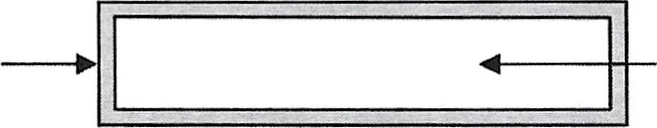
Colored paperWhite paper, pictures
Creates borderor graph/tables Page 12

GUIDELINES FOR SCIENCE FAIR LOG BOOK
LOG BOOK INSTRUCTIONS
What is a Log Book? It is a record of your experiment (like a journal) that is kept in a composition notebook. A composition notebook does not have pages that can be torn out. Everything written in the logbook stays.
What should be in your Log Book? When you begin your experiment you need to record the following in your logbook:
- All of your research prior to choosing your project. (Include all books, websites and other sources that you researched)
- Proposal (each section must be labeled). Make sure that all the corrections from the original proposal have been made before you copy into log book.
  - The Problem (in the form of a question)
  - Hypothesis -- written as an if. . . . then statement.
Independent Variable
Control Variable
Dependent Variable
List of the all the Materials that you actually use in the experiment. (This may change slightly from your original proposal).
List and number the steps/procedures that you are following for your experiment.
Drawings or illustrations- Illustrate the experimental design and work in progress. Include sketches and diagrams of the setup of your experiment.
- Data- You need to record everything that happens 111 your experiment neatly. Use a ruler to make neat data charts. Be sure to write observations neatly that can be read by others. Please date all entries when they occur. Include photos and drawing if it helps show what has occurred,
If you run into problems, record the roblem and how you plan to solve the problem in your Log Book. Research possible solutions. If it doesn't solve the problem come up with a new plan and try that.
Include question and ideas for further experiments or questions for your teacher.
4, Explain in a few sentences the reasons why you choose this topic for your experiment. What about this subject interests you?
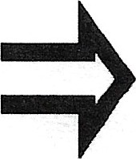
Your log book will be graded on how much of the above criteria are included in your log book.

LOG BOOK CHECKLIST
The Problem (in the form of a question)
Hypothesis (wHtten as an if. , then statement). Independent Variable (only one)
Control Variable (must include at least four)
Dependent Variable (what is measured)
List ofthe all the Materials that you actually use in the experiment.

(This may change slightly from your original proposal).
List and number the steps/procedures that you are following for your experiment. Put in number format.
Drawings or illustrations- Illustrate the experimental design and work in progress.
Include sketches and diagrams of the setup of your experiment,
Data- You need to record everything that happens in your experiment neatly. Use a liller to make neat data charts. Be sure to write obsewations neatly that can be read by others. Please date all entries when they occur. Include photos and drawing if it helps show what has occulTed.
Science Project Grading Rubric

POINTS Display
 Is the display neatly organized and the design pleasing? (-1 to -5)
Are the Scientific Question, Hypothesis, Materials, Procedures, Results, and Conclusion labeled? (-2 each)
Is there a Title If not, -5 Is it in the proper location? (-1 each)
Is the student's name and class number below the Title? (-1 each) Is the teacher's name and grade level below the Title? (-1 each)
Are there at least 3 appealing pictures that pertain to the experiment? (-1 each)

Scientific Question
Is there a Scientific Question? (-10)
Is the Scientific Question labeled? (-2)
Is the Scientific Question in the proper location? (-1)
Does the question end with a "?" (-1)
Does the question make sense? (-1 to -5)

 Hypothesis
Is there a Hypothesis? (-10)
Does the Hypothesis end with a period? (-1)
Does the Hypothesis relate to the experiment performed? (-1 to -7)
Does the Hypothesis answer the scientific question? (-5) Does the Hypothesis make sense? (-1 to -5)

 Materials

Is there a list of materials? (-10)
Is the list of materials in the proper location? (-1)
Is it difficult to read the list? (-2)
Are all the items included that were necessary for the experiment? (-2 each)

110 Procedures
Is there a list of procedures (-10)
Is the list of procedures in the proper location (-1)
Are the procedures numbered? (-2)
Does the list have fewer than 5 procedures? (-2 each <5)
Does each procedure make sense? (-1 per confusing procedure)
Can the list be followed to replicate the experiment? (-1 to -4)
Is the "Gather all materials" your first procedure? (-1)
Is "Record results" your last procedure? (-1)

 Results
Are the results on the board? (-10)
Are the results in the proper location? (-1)
Are the results displayed in table or graph form? (-9)
Are the results easy to read? (-3)
Is the table or graph constructed accurately? (-10)
If GRAPH, is the Y axis properly labeled (-2 partial, -4 not at all)
If GRAPH, is the X axis properly labeled (-2 partial, -4 not at all)
If TABLE, is the table properly labeled? (-4 partial, -8 not at all)

/5 TRIALS
Is there evidence of at least 3 experimental trials? (-1 for each missing trial)

Conclusion
Is there a conclusion? (-10)
Is the conclusion in the proper location? (-1)
Does the conclusion end with something other than period? (-1)
Does the conclusion respond to the question? (-2 to -5) Does the conclusion fit given the hypothesis? (-2 to -5)

 Background Information
Is there Background Information? (-10)
Is the Background Information in the proper location? (-1)
Is the Background Information clearly labeled using headings? (-1)
Does the Background Information speak to the experiment topic? (-1 to -9)

/5 Bibliography
Is there a bibliography? (-5)
Is the bibliography in the proper location? (-1)
Is the bibliography clearly labeled? (-1) Is the bibliography accurate? (-1)

/5 Log or Journal (on table in front of the display)
Is there a log or journal included (scientific notes)? (-5)
Is the log hand written? (-1)
Is the log or journal clearly labeled? (-1)
Does the log or journal include all results reported regarding the experiment? (-1 to -3)

Further Questions — Extra Credit (+1 to +5)
Explanation of extra points

Total Points (possible 100)
NOTE: Please check your work for spelling errors! 1-3 points will be deducted for spelling errors in each section depending upon the number and if the error is in the title/heading or simply in the body of the written work for that section. These deducted points will have a "sp" and or - to denote that spelling errors caused the deduction.

